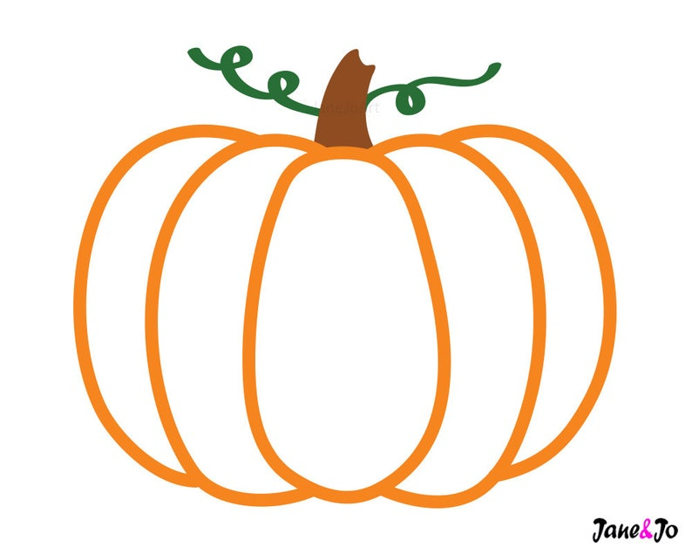
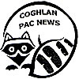

Thanksgiving Food Drive

Hey Coghlan! Now is the time to
help your Community!

Coghlan PAC will be running a Food Drive for the Aldergrove Food Bank beginning Monday September 27 through Monday October 4. Please send your items with your child to their classroom.

We will be keeping a tally of the number of items brought in and the class with the most number of items will be rewarded with a pizza party! Let’s all work together to make the holiday brighter for everyone in our community. Thank you for your generosity.

Wish List Items:

Cash Donations (Please note that cash donations offer us the most flexibility)
Visit: langleyfoodbank.com
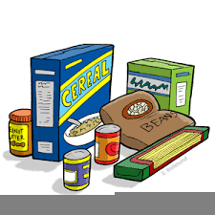
Grocery store or general merchandise gift cards
Canned Meats and Fish
Canned Fruits and Vegetables
Sandwich Spreads (jam, peanut butter)
Canned Stews
Rice and Pasta
Canned Tuna, Salmon, Sardines, Turkey, Ham
Personal Care Products
Baby Food, Formula, and Cereal
Diapers (especially larger sizes)
Case lots if possible are much appreciated!
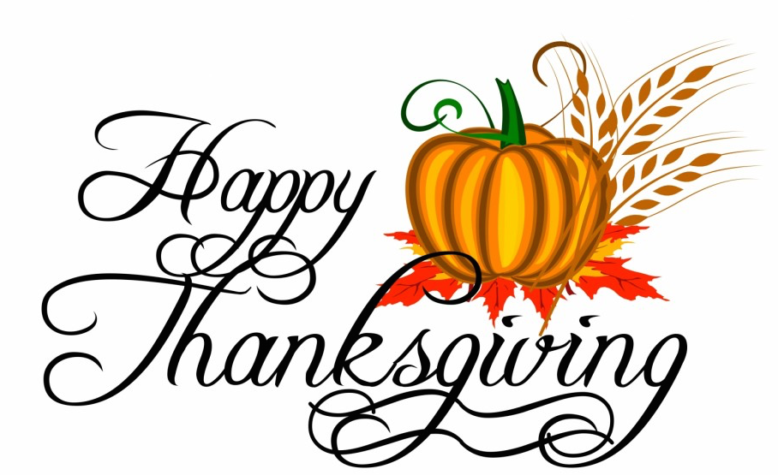
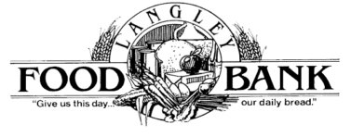

Food Bank

Aldergrove Location

