Dear Coghlan Families,

We will be holding our Meet the Teacher Day on September 28 from 2:45-4:45PM. It will be an opportunity to meet your child’s teacher and have a visit around the classroom. If you would like to meet your child’s teacher but you are unable to meet on September 28, please contact the teacher directly. Once you arrive at the school, please lineup where your child would normally lineup before entering their classrooms at the beginning of the school day. In order to maintain space, we asked that families with last names between A-L come between 2:45-3:30pm and last names M-Z come between 3:45-4:45pm. The classroom teacher will meet you at the lineup and welcome in three families at a time (10 minute intervals).
As per the Health Guidelines our families are to go through the daily health check before arriving at school and wear your masks upon entering the school building. If any parents have a medical condition and/or are unable to wear a mask, please arrange a time slot with the classroom teacher so that we can arrange a meet and greet outside. Just a note, that this is a meet the teacher, and not a parent teacher conference. We will be having parent teacher conferences on October 20 and October 21. More details will be shared prior to the conferences.
We look forward to meeting our families throughout the school year and we appreciate your patience and flexibility. It truly takes an entire community to support our children.

Please contact Mr. Alan Joo if you have any questions.

Kindest regards,
Mr. Alan Joo
Principal of Coghlan Fundamental Elementary School

Flow of Traffic at Pickup and Dropoff
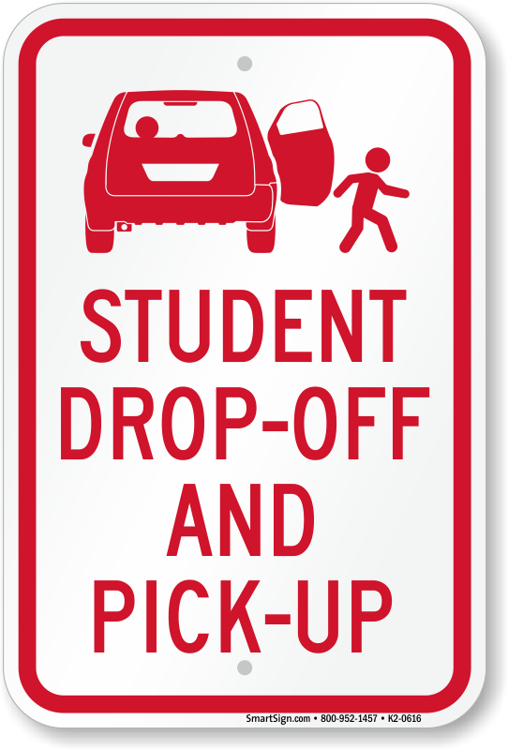
Thank you Coghlan families for working together to try to make drop-off and pick-up as safe and fluid as possible. We appreciate you following the signs for flow of traffic based on your last name. Just a reminder that if your last name is from A-F and M-S, please continue to drive around the parking lot until your child is available to be picked up. You may enter into the second lane nearest to the gym if you see your child waiting in line, to help with quick drop-off and pick-up. Families with last names that start with G-L and T-Z can turn left as you enter into the parking lot. This has truly helped with the flow of traffic. We appreciate your patience and support as we are a community where majority of our families commute.

